ASSIGNMENT 3 SUBMISSION: listing page
SUMITTED BY : KEERTHANA PRABAHARAN
DATE : JULY 18 2026

1 . PROJECT DESCRIPTION
This is a custom responsive internship listings page built with HTML and CSS that showcases four virtual internship programs (Web Development, App Development, Python, and Java) in a visually engaging card-based layout. Each card features a distinct accent color, icon, and program details, with smooth hover animations and working "View Details" buttons to create an attractive, modern user experience.
2 . SOURCE CODE

<!DOCTYPE html>
<html lang="en">
<head>
<meta charset="UTF-8">
<meta name="viewport" content="width=device-width, initial-scale=1.0">
<title>Internships</title>
<link rel="preconnect" href="https://fonts.googleapis.com">
<link href="https://fonts.googleapis.com/css2?family=Sora:wght@600;700;800&family=Inter:wght@400;500;600&display=swap" rel="stylesheet">
<style>
:root{
--bg1:#1a1035;
--bg2:#2b1657;
--card:#ffffff;
--ink:#1c1730;
--mute:#6b6482;
--accent-web:#5b6bf7;
--accent-app:#f76b9b;
--accent-py:#2fbf8f;
--accent-java:#ff9d4d;
--line:#ece9f7;
}
*{box-sizing:border-box;}
body{
margin:0;
min-height:100vh;
font-family:'Inter',sans-serif;
background:
radial-gradient(circle at 15% 10%, rgba(91,107,247,0.35), transparent 45%),
radial-gradient(circle at 85% 90%, rgba(247,107,155,0.28), transparent 45%),
linear-gradient(160deg, var(--bg1), var(--bg2));
padding:70px 6vw 90px;
color:var(--ink);
}
.page-head{ text-align:center; margin-bottom:60px; }
.page-head span{
display:inline-block; color:#c9bfff; font-size:.78rem; letter-spacing:3px;
text-transform:uppercase; font-weight:600; margin-bottom:14px;
}
.page-head h1{
font-family:'Sora',sans-serif; font-size:clamp(2.2rem,5vw,3.2rem);
color:#fff; margin:0; font-weight:800; letter-spacing:-1px;
}
.page-head p{ color:#b9b0dc; max-width:480px; margin:14px auto 0; font-size:1rem; }

.grid{
display:grid;
grid-template-columns:repeat(auto-fit,minmax(300px,1fr));
gap:32px;
max-width:1100px;
margin:0 auto;
}

.card{
position:relative;
background:var(--card);
border-radius:22px;
padding:34px 30px 30px;
box-shadow:0 20px 50px rgba(15,8,40,0.35);
overflow:hidden;
transition:transform .35s ease, box-shadow .35s ease;
}
.card::before{
content:'';
position:absolute; top:0; left:0; right:0; height:6px;
background:var(--accent);
}
.card:hover{ transform:translateY(-10px); box-shadow:0 30px 60px rgba(15,8,40,0.45); }

.card-icon{
width:52px; height:52px; border-radius:14px;
display:flex; align-items:center; justify-content:center;
font-size:1.5rem; margin-bottom:18px;
background:color-mix(in srgb, var(--accent) 14%, white);
}

.card h2{
font-family:'Sora',sans-serif; font-size:1.25rem; margin:0 0 4px; line-height:1.3;
}
.card .badge{
display:inline-block; font-size:.7rem; font-weight:700; letter-spacing:.5px;
text-transform:uppercase; color:var(--accent); background:color-mix(in srgb, var(--accent) 12%, white);
padding:4px 10px; border-radius:20px; margin-bottom:16px;
}

.detail-list{ list-style:none; margin:0 0 26px; padding:0; }
.detail-list li{
display:flex; align-items:center; gap:10px;
font-size:.92rem; color:var(--mute); padding:7px 0;
border-bottom:1px dashed var(--line);
}
.detail-list li:last-child{ border-bottom:none; }
.detail-list li .dot{
width:7px; height:7px; border-radius:50%; background:var(--accent); flex-shrink:0;
}
.detail-list li strong{ color:var(--ink); font-weight:600; }

.btn{
display:inline-flex; align-items:center; justify-content:center; gap:8px;
width:100%; padding:13px 20px; border:none; border-radius:12px;
background:var(--accent); color:#fff; font-weight:700; font-size:.95rem;
text-decoration:none; cursor:pointer;
transition:transform .25s ease, filter .25s ease;
}
.btn:hover{ transform:translateY(-3px); filter:brightness(1.08); }
.btn:active{ transform:translateY(0); }

.web { --accent:var(--accent-web); }
.app { --accent:var(--accent-app); }
.py { --accent:var(--accent-py); }
.java { --accent:var(--accent-java); }

@media (max-width:480px){
body{ padding:50px 5vw 60px; }
}
</style>
</head>
<body>

<div class="page-head">
<span>Now Hiring Interns</span>
<h1>Internships</h1>
<p>Hands-on virtual programs to launch your tech career — pick your track and get started.</p>
</div>

<div class="grid">

<div class="card web">
<div class="card-icon">💻</div>
<span class="badge">Web Track</span>
<h2>Web Development<br>Internship Program</h2>
<ul class="detail-list">
<li><span class="dot"></span> Duration: <strong>&nbsp;1–2 months</strong></li>
<li><span class="dot"></span> Location: <strong>&nbsp;Virtual</strong></li>
<li><span class="dot"></span> Stipend: <strong>&nbsp;—</strong></li>
<li><span class="dot"></span> Start date: <strong>&nbsp;05/11/2023</strong></li>
</ul>
<a class="btn" href="https://example.com/web-development-internship" target="_blank">View Details →</a>
</div>

<div class="card app">
<div class="card-icon">📱</div>
<span class="badge">App Track</span>
<h2>App Development<br>Internship Program</h2>
<ul class="detail-list">
<li><span class="dot"></span> Duration: <strong>&nbsp;1–2 months</strong></li>
<li><span class="dot"></span> Location: <strong>&nbsp;Virtual</strong></li>
<li><span class="dot"></span> Stipend: <strong>&nbsp;—</strong></li>
<li><span class="dot"></span> Start date: <strong>&nbsp;05/11/2023</strong></li>
</ul>
<a class="btn" href="https://example.com/app-development-internship" target="_blank">View Details →</a>
</div>

<div class="card py">
<div class="card-icon">🐍</div>
<span class="badge">Python Track</span>
<h2>Python Programming<br>Internship Program</h2>
<ul class="detail-list">
<li><span class="dot"></span> Duration: <strong>&nbsp;1–2 months</strong></li>
<li><span class="dot"></span> Location: <strong>&nbsp;Virtual</strong></li>
<li><span class="dot"></span> Stipend: <strong>&nbsp;—</strong></li>
<li><span class="dot"></span> Start date: <strong>&nbsp;05/11/2023</strong></li>
</ul>
<a class="btn" href="https://example.com/python-programming-internship" target="_blank">View Details →</a>
</div>

<div class="card java">
<div class="card-icon">☕</div>
<span class="badge">Java Track</span>
<h2>Java Programming<br>Internship Program</h2>
<ul class="detail-list">
<li><span class="dot"></span> Duration: <strong>&nbsp;1–2 months</strong></li>
<li><span class="dot"></span> Location: <strong>&nbsp;Virtual</strong></li>
<li><span class="dot"></span> Stipend: <strong>&nbsp;—</strong></li>
<li><span class="dot"></span> Start date: <strong>&nbsp;05/11/2023</strong></li>
</ul>
<a class="btn" href="https://example.com/java-programming-internship" target="_blank">View Details →</a>
</div>

</div>

</body>
</html>

3. OUTPUT ( SCREENSHOT)
4 cards for Web Dev, App Dev, Python, and Java — each with its own accent color and icon (💻 blue, 📱 pink, 🐍 green, ☕ orange) so they're instantly distinguishable at a glance
LINK : Internships
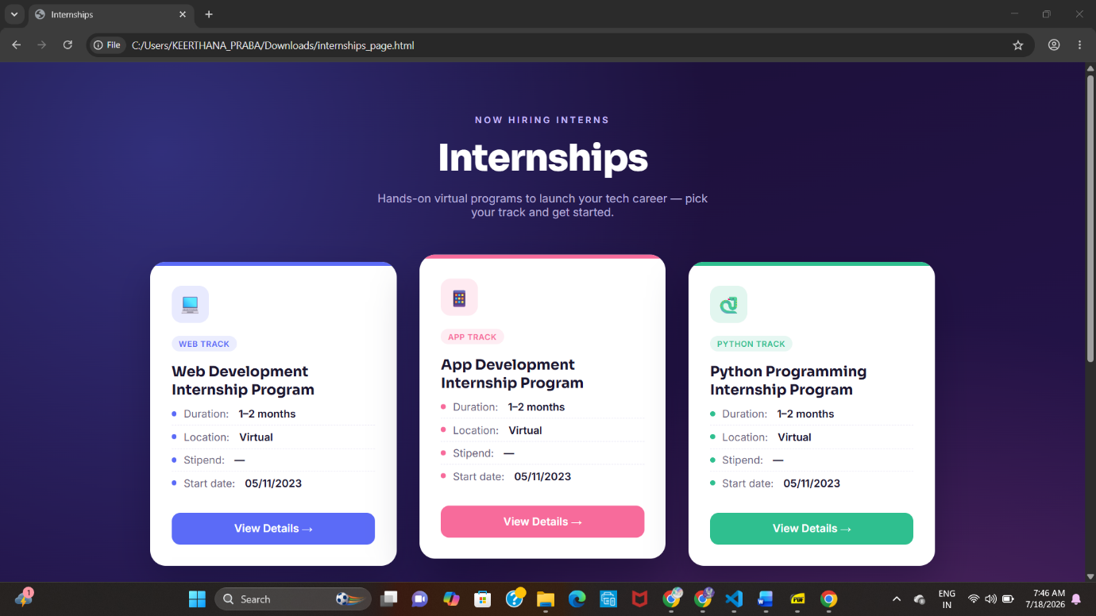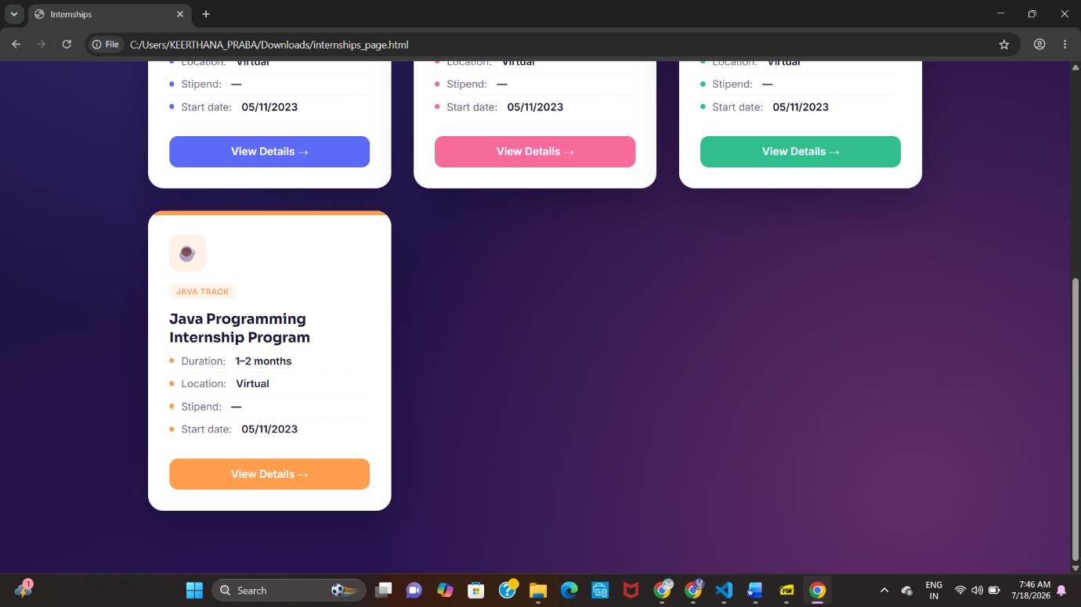

4. CONCLUSION
Overall, this project reinforced that good design isn't just decoration — it's a powerful tool for better user experience, higher retention, and stronger brand impression. Small, consistent details (colors, shadows, interactions) compound to create something significantly more professional and engaging.

